K.KALA WORD FILE OF POWER BI OF HAI MINI PROJECT IN HOSPITAL DATA SET 25.05.26
1.CREATE BASIC MEASURES – AVERAGE HOSPITAL SCORE
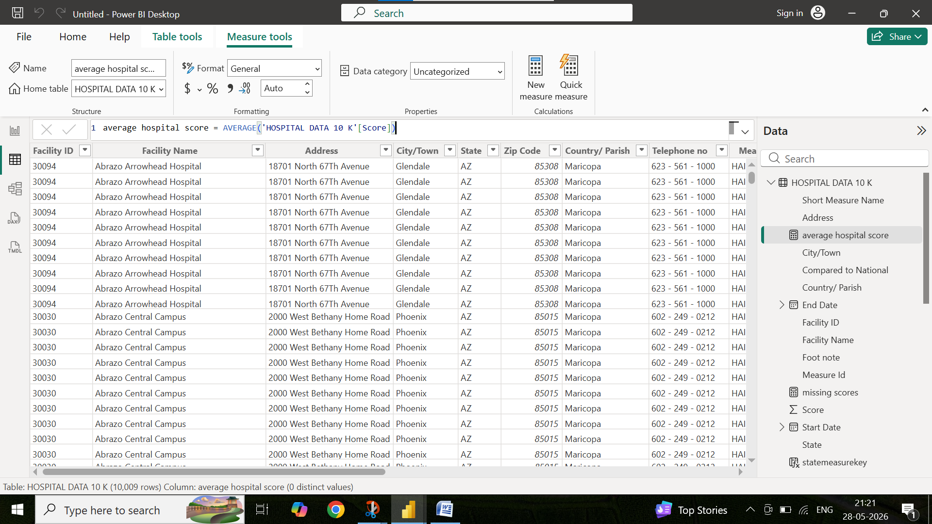
2.AVERAGE STATE SCORE
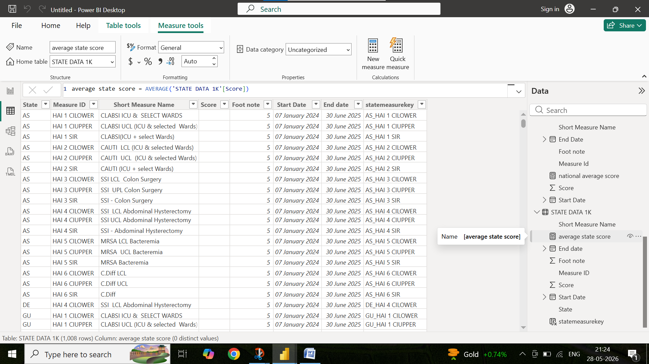

3.AVERAGE NATIONAL SCORE
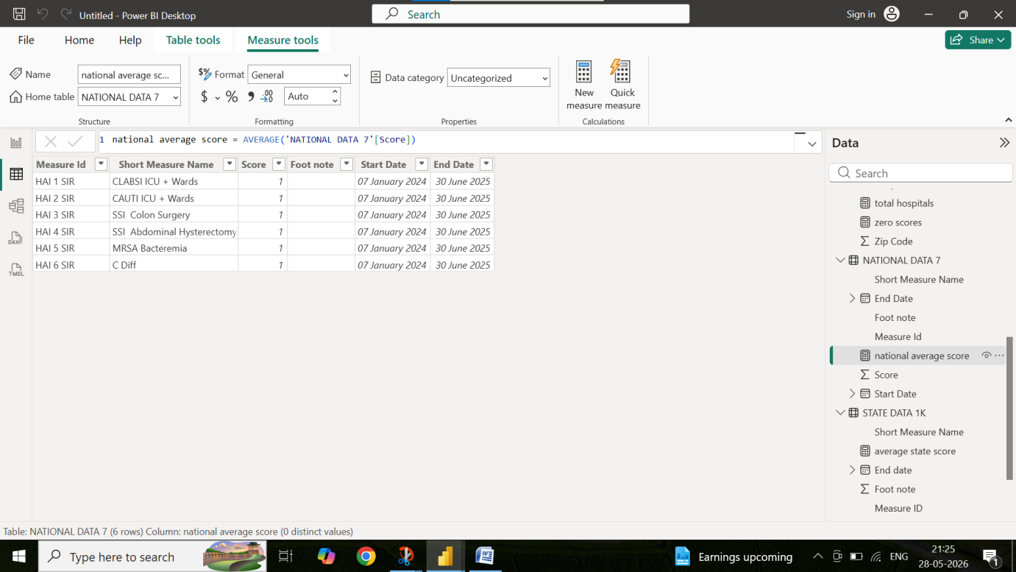
4.TOTAL HOSPITALS
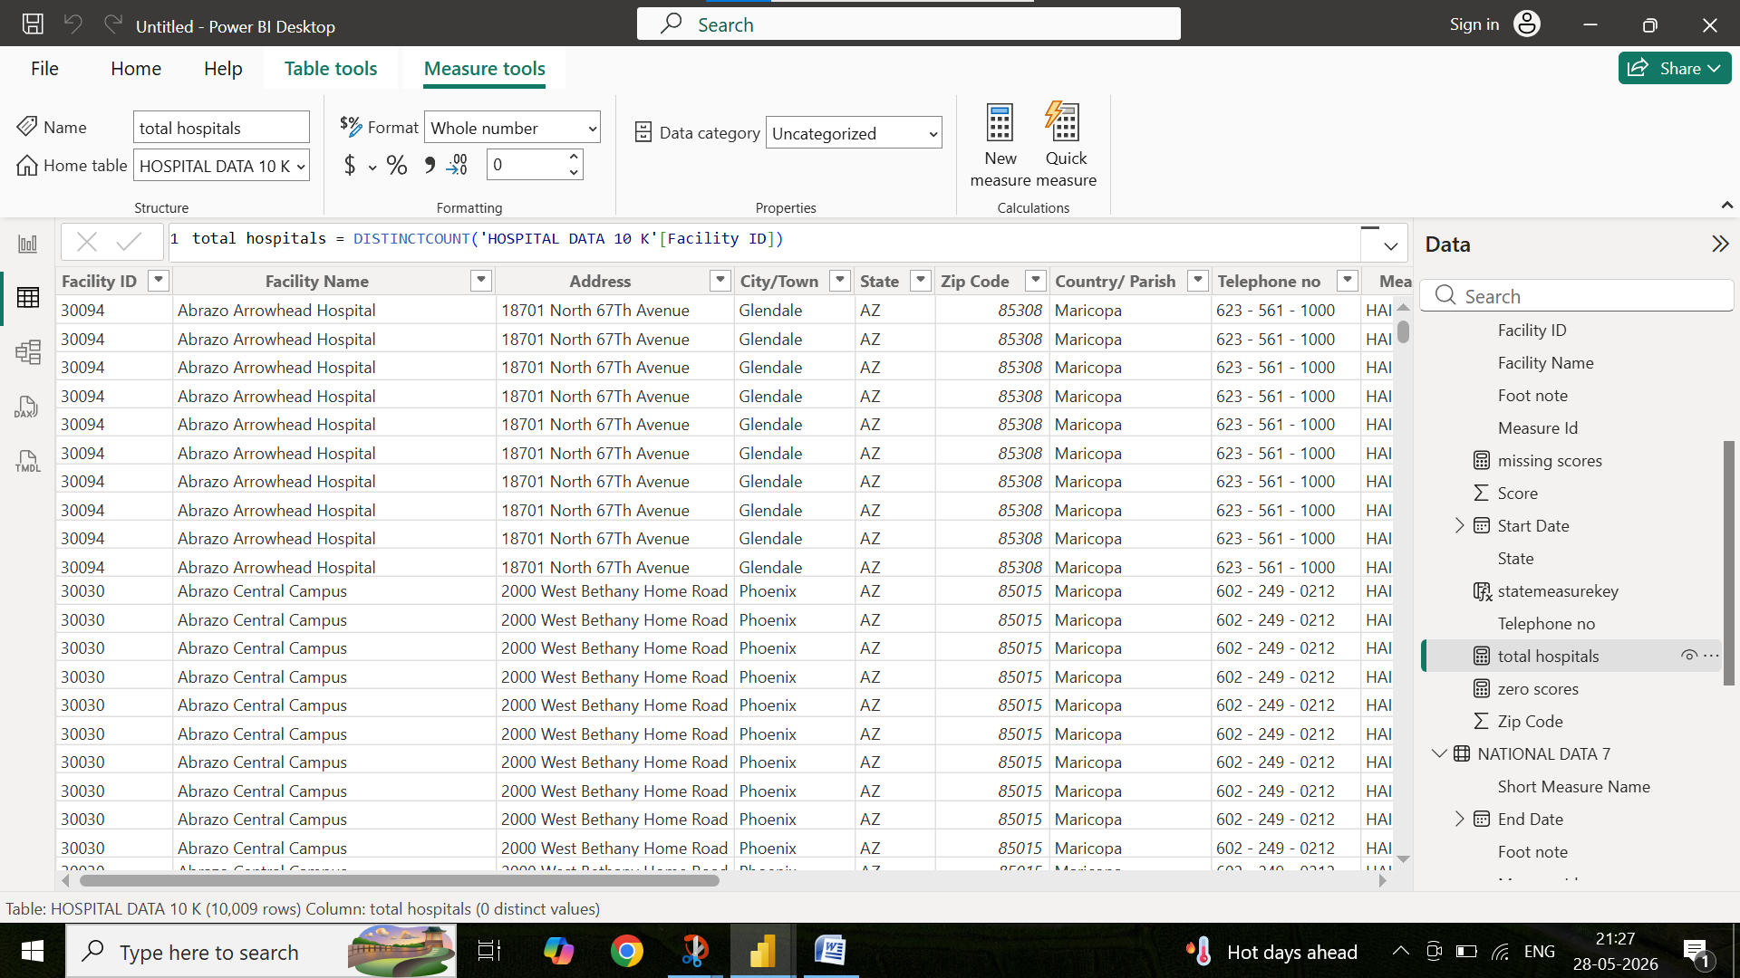

5.MISSING SCORES
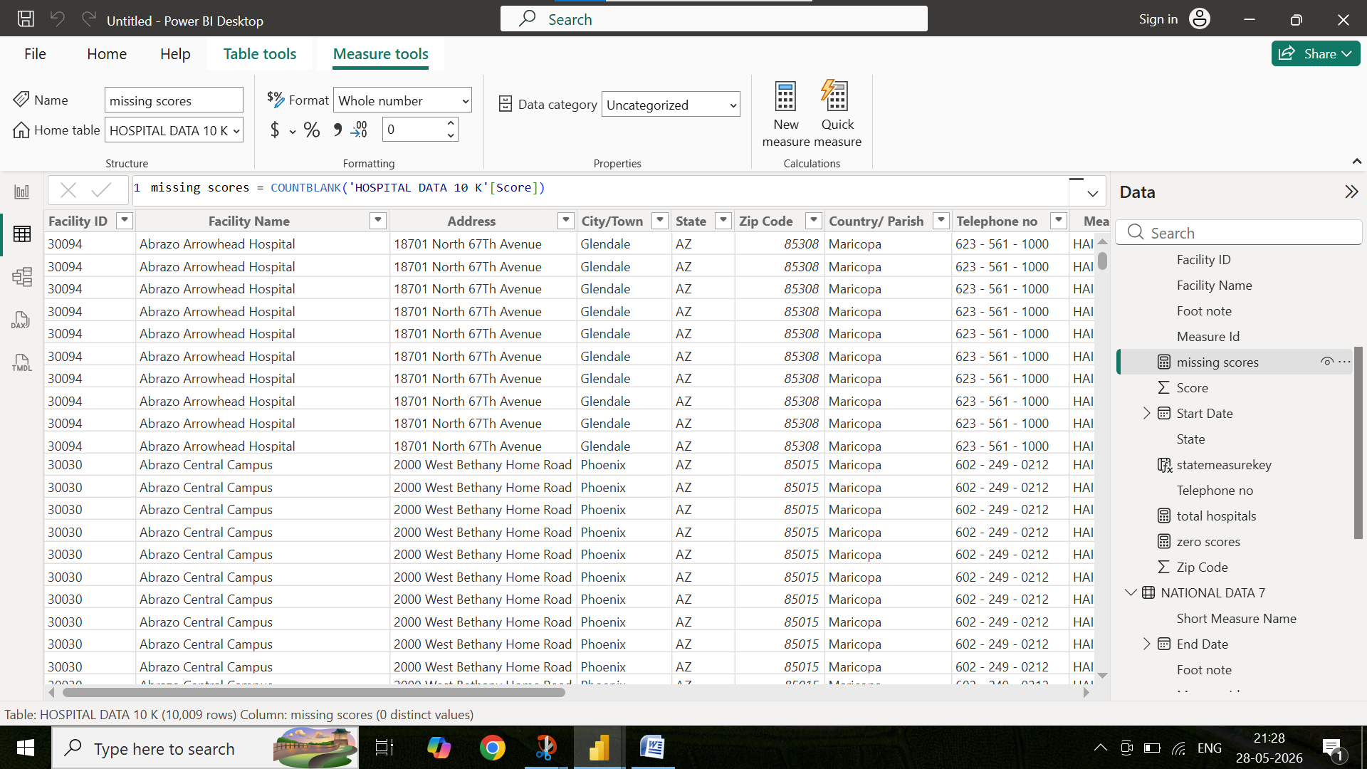

6. ZERO SCORES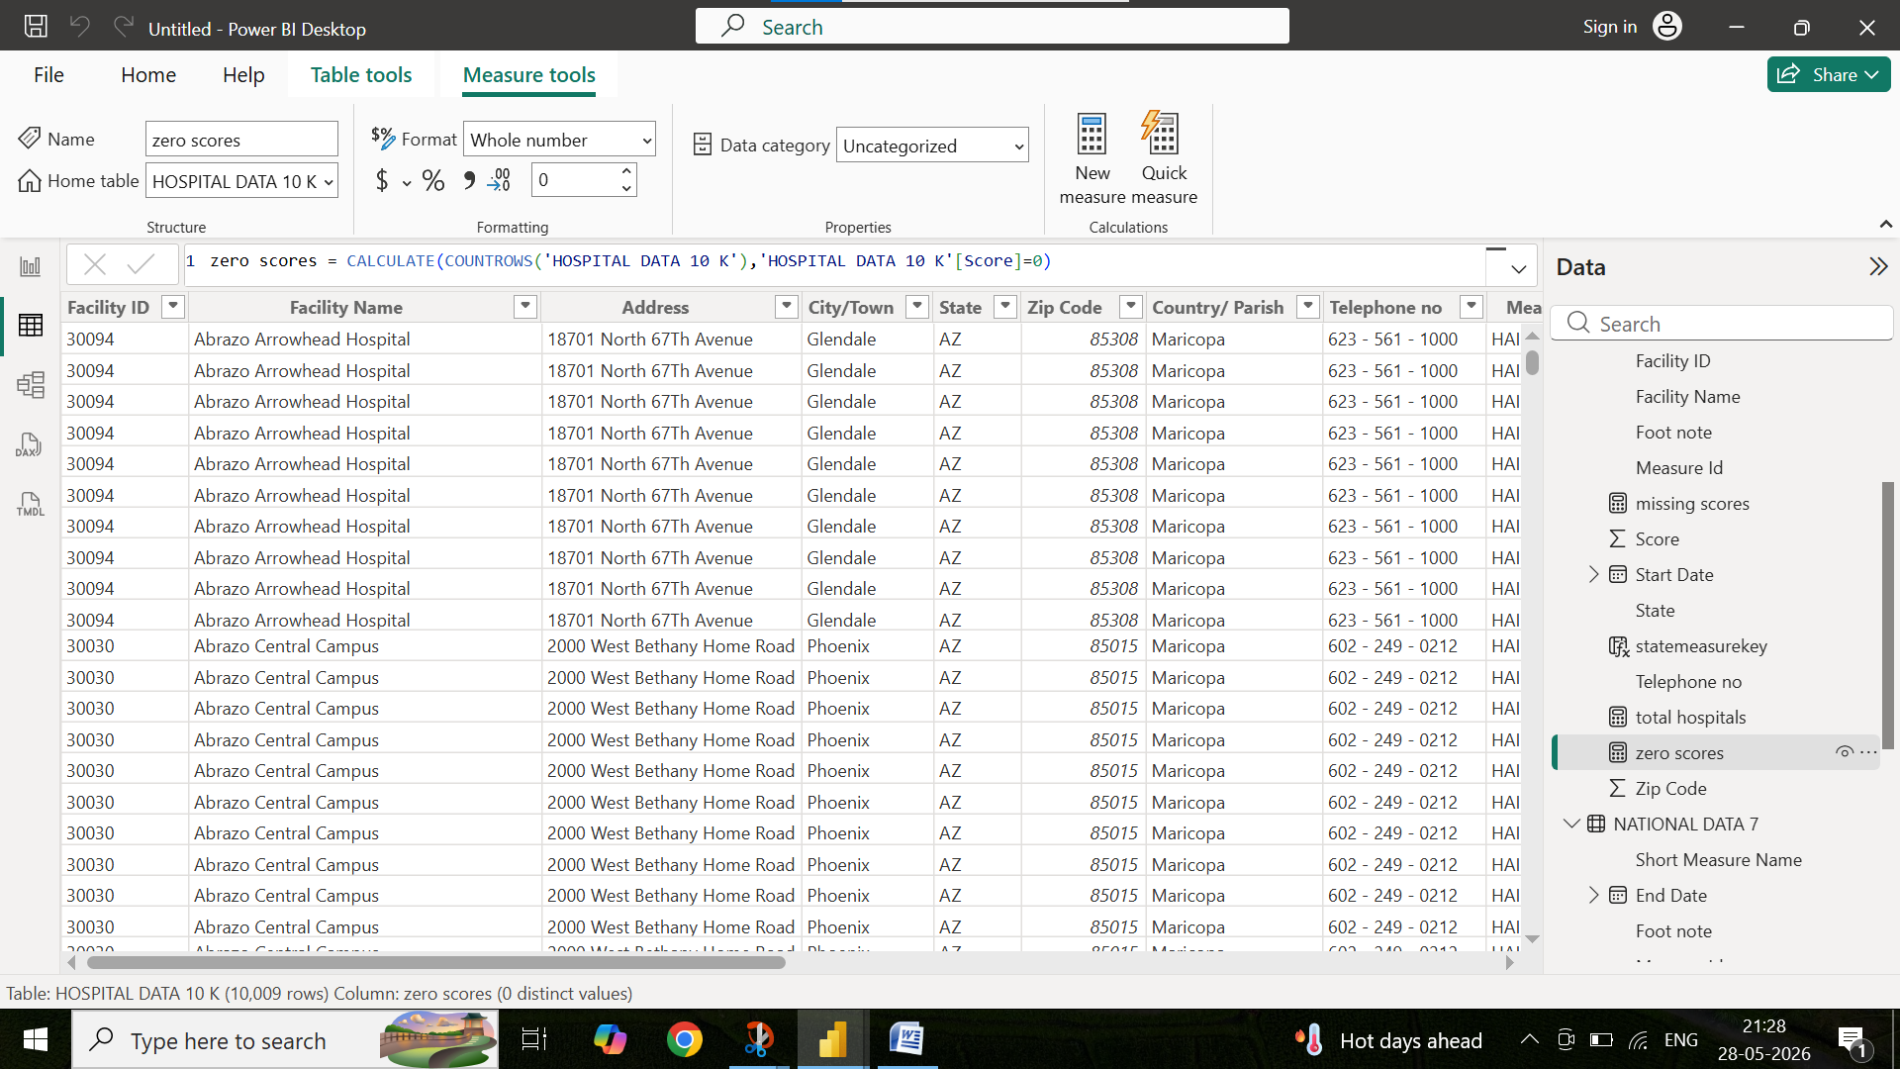

KPI CARDS , 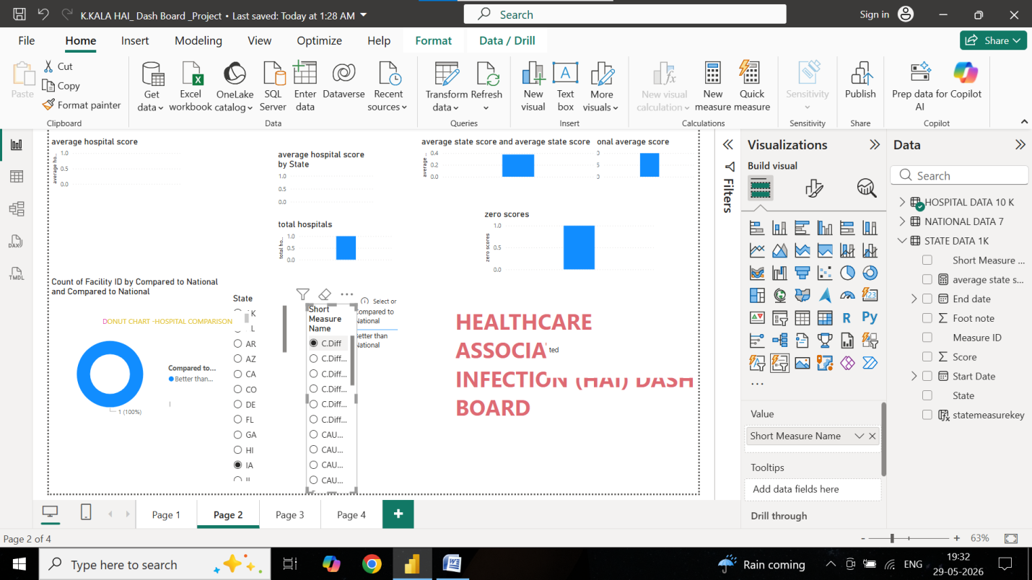
LIST SLICER USED
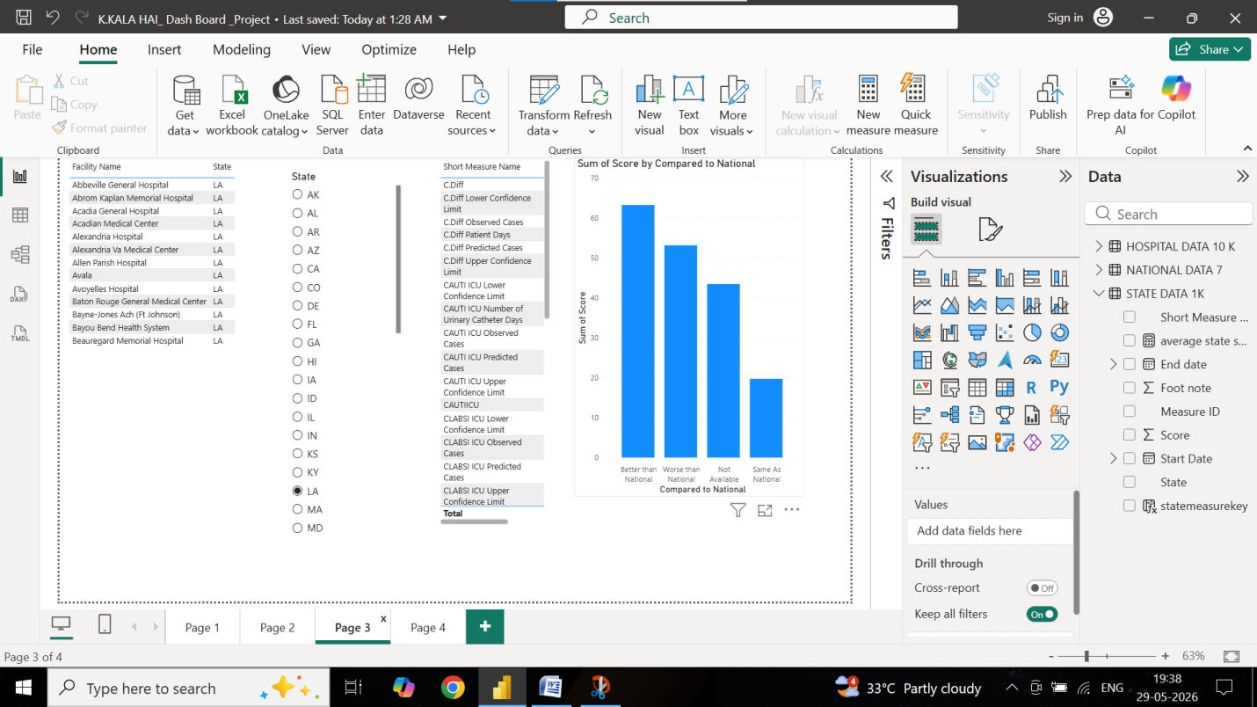

COMPARISION WITH NATIONAL BENCH MARK AND FOOT NOTE FOR HAI DASH BOARD ANALYSIS
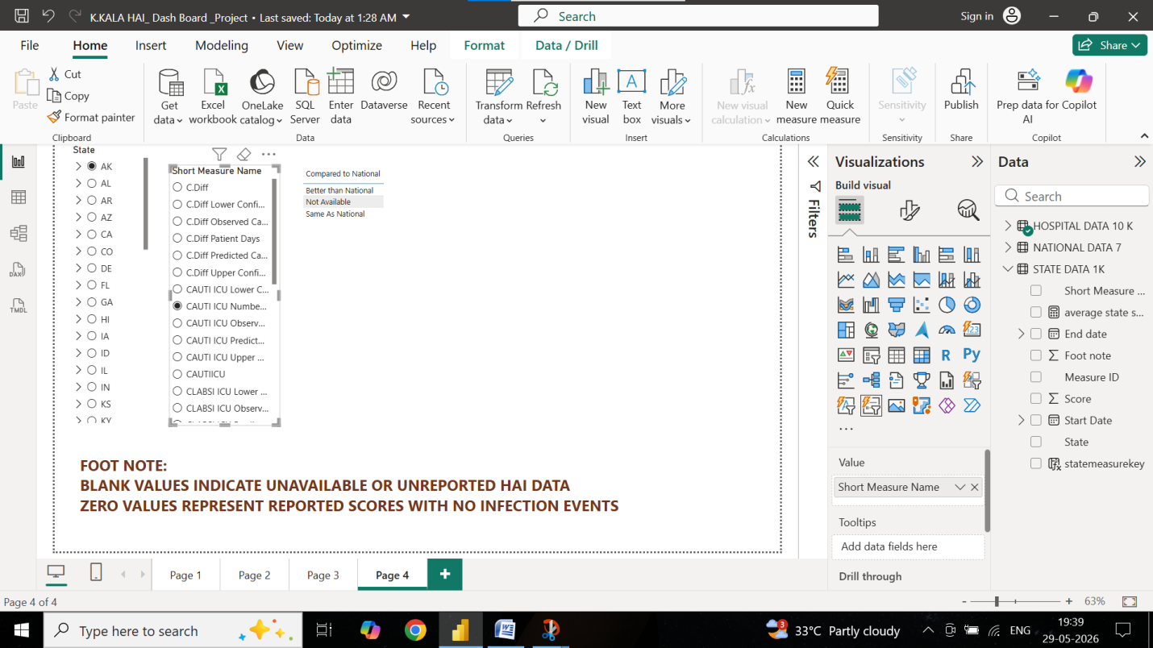
HAI DASH BOARD WORKING ANDANALYSIS DONE
